Lab 08 Write-Up

By: Arielle Wood

Part 1:

1. Discuss the effect of utilizing varying ISODATA parameter values on the resultant classified images. Visually, are there any conclusions/recommendations that you can draw from these results in terms of what parameter settings may be advantageous to utilize in terms of improving classification accuracy?

**ISODATA DEFAULT:**

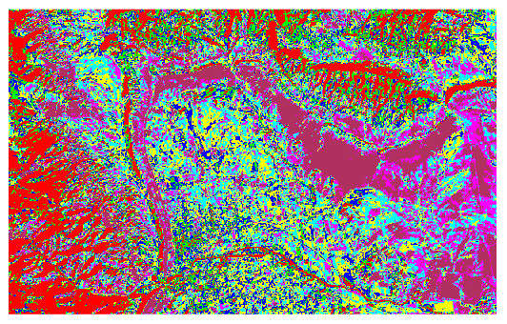

**ISODATA WITH 20 ITERATIONS:**

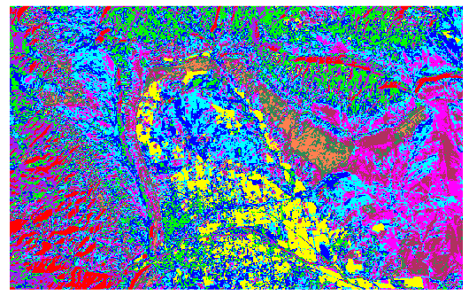

**ISODATA THRESHOLD OF 20:**

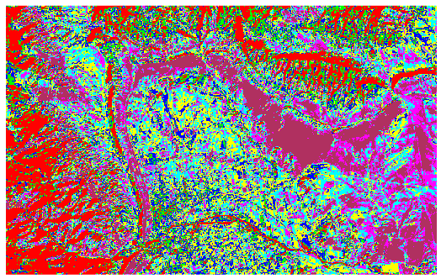

**ISODATA WITH STANDARD DEVIATION OF 0.5:**

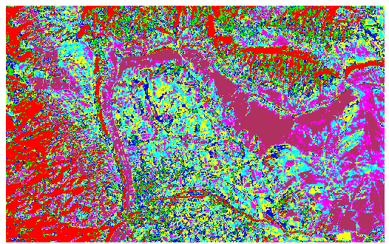

**ISODATA WITH A PIXEL CLASS OF 20, AND ITERATED 5 TIMES:**

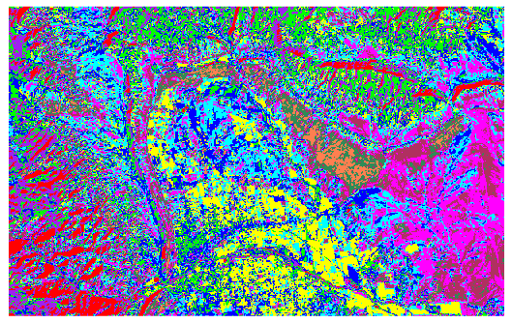

There is no difference between the default ISODATA, the ISODATA with a threshold of 20 and the ISODATA with the standard deviation of 0.5. This shows that changing these parameters to the different values I selected caused no effect or change in the outputted representation from the default. The only change that caused a notable difference was changing the times it was iterated. The increased threshold caused a notable difference and increase in detail from the default ISODATA classification. The iteration of 20 output compared to the iteration of 5 with a pixel class of 20 are very similar. Only when linked and zoomed in can small changes be noted. The classification with the iteration of 5 and the pixel class of 20 shows the most detail in showing changes in land cover. My recommendation for future analysts in using ISODATA classification is to increase the number of iterations and increase the pixel class for the best detail.

Below is the zoomed in classification of the iteration of 20 map on the right compared to the iteration of 5 with a pixel class of 20 on the left:

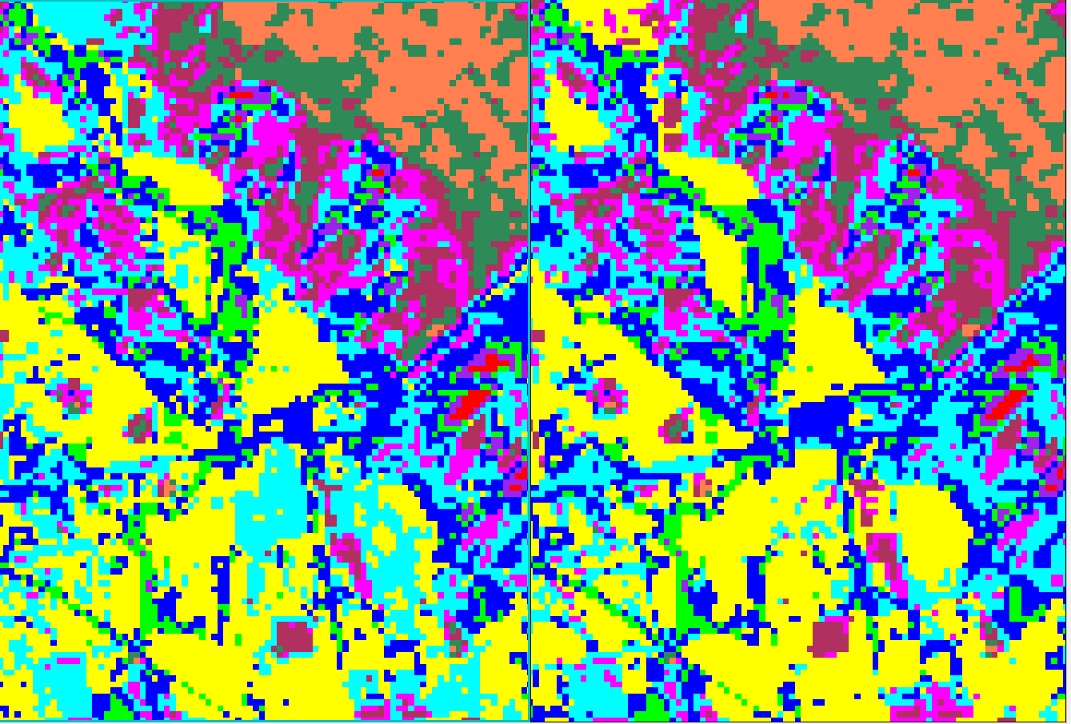

Part 2:

1. Discuss the effect of varying the probability threshold value setting. Visually, are there any conclusions/recommendations that you can draw from these results in terms of what threshold settings may be advantageous to utilize? How did the classification change when you added a new training area?

**MAXIMUM LIKELIHOOD WITH NEW ROI AND SINGLE THRESHOLD OF 70%:**

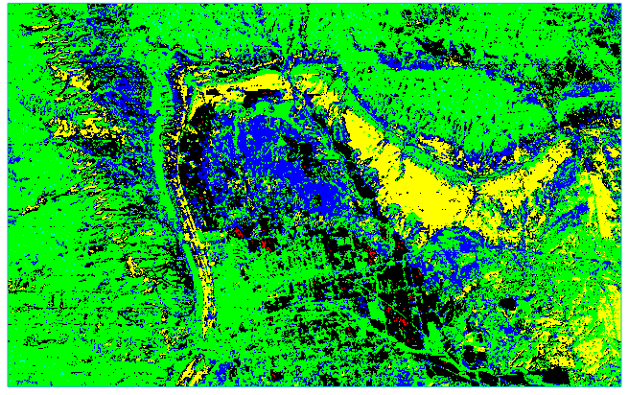

**MAXIMUM LIKELIHOOD WITH CLASS ROI AND SINGLE THRESHOLD OF 70%:**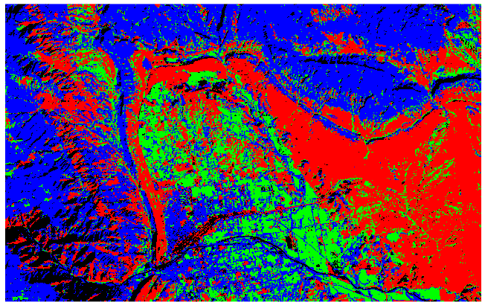

**MAXIMUM LIKELIHOOD WITH CLASS ROI AND NO THRESHOLD:**

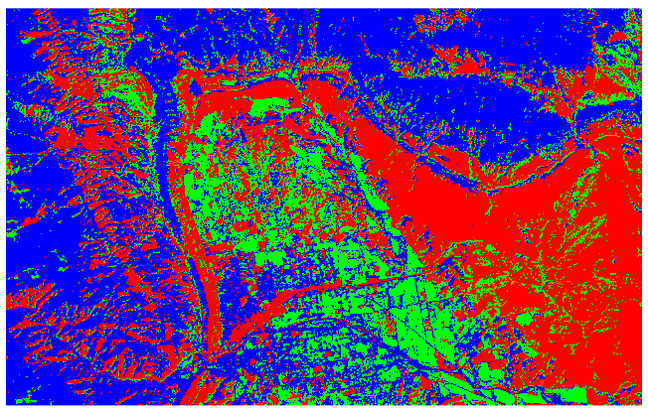

Changing the probability threshold changes the amount of land cover identified as different the classified land through the ROI as ‘unclassified.’ This does increase the amount of different land cover types able to be identified. The ‘unclassified’ area could be used to create a new ROI and output a better maximum likelihood classification. I recommend a high threshold since it will determine more land cover to classify as different from the training sample. This will improve your analysis and show more land cover types and inform you to improve the ROI for future analysis. My classification became less detailed with employing a new ROI. This was because my areas of interest were too small and because I deleted the previous areas from the class ROI. The computer did not have enough pixels in each area of land cover type to create a good classification. If the ROI is a good representation of the land cover types, the classification will have good detail and be accurate.

1. Create 2 maps: 1 is ISODATA default, 1 is Max Likelihood default.

ISODATA DEFAULT:



MAXIMUM LIKELIHOOD WITH ‘NONE’ AS THRESHOLD:



|  |
| --- |
| Legend: |
| * Blue is the forested area * Red is the arid mountainous area * Green is the agricultural fields |